Work-case 6

1. Several command interpreters must be installed in the workspace of the operating system (in addition to bash, there are 2 more of your choice): робив Бурбан Данило

- What teams can do it;

- Briefly describe the capabilities of each of them.

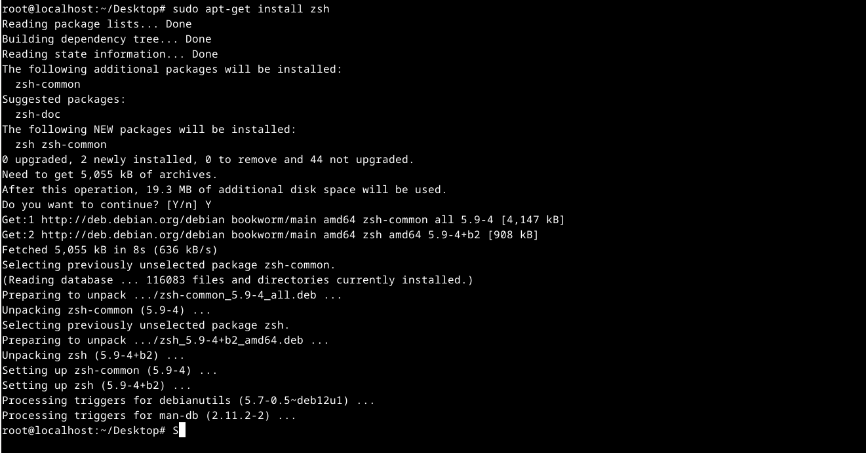

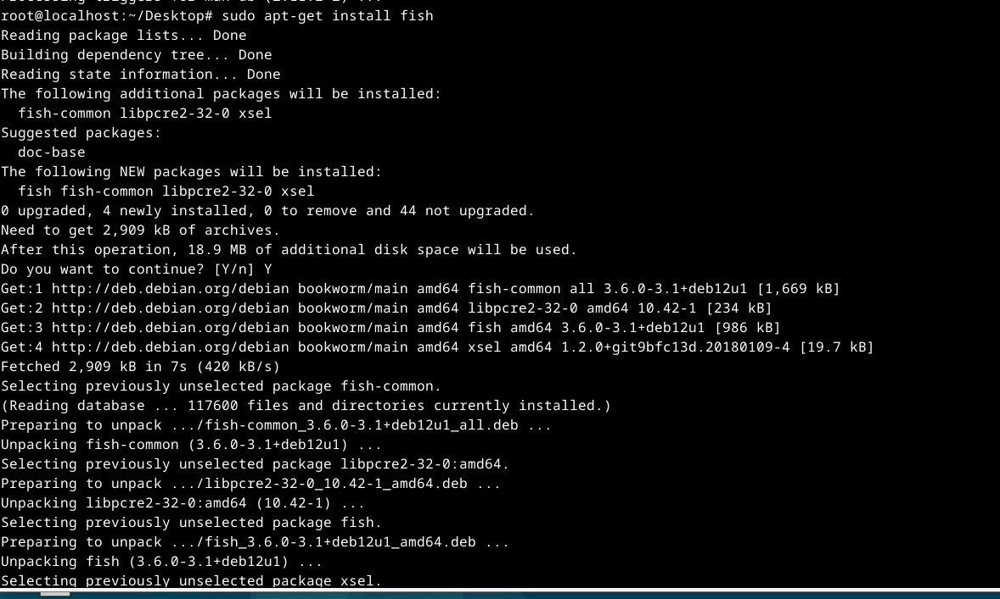

Z shell (zsh): A powerful command interpreter with a significant set of functions. It has an extensive system of plugins, the ability to customize the appearance and auto-completion of commands.

Friendly Interactive Shell (fish): A modern shell that offers an intuitive user interface with command auto-completion, command history, and scripting support.

2. It is necessary to create 10 new users in your system and distribute them to groups:

- Technical support (technical support, system administrators);

- Developers (developers, technical specialists of their profile);

- Financiers (accounting, economists, etc.);

- Founders (management);

- Guests (guests).

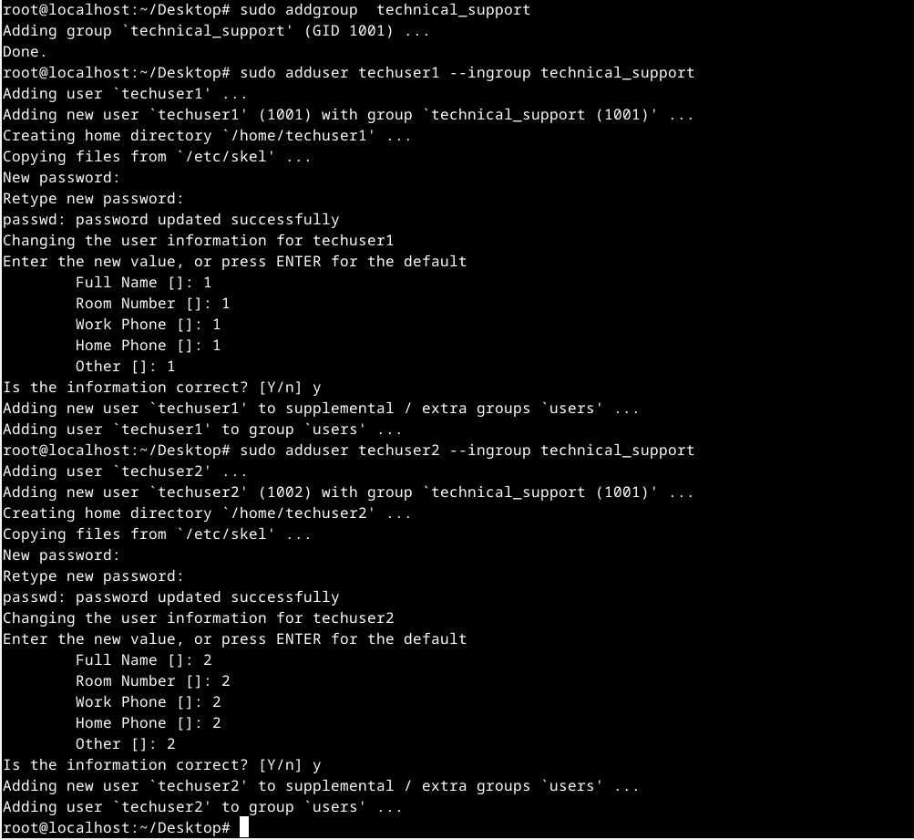

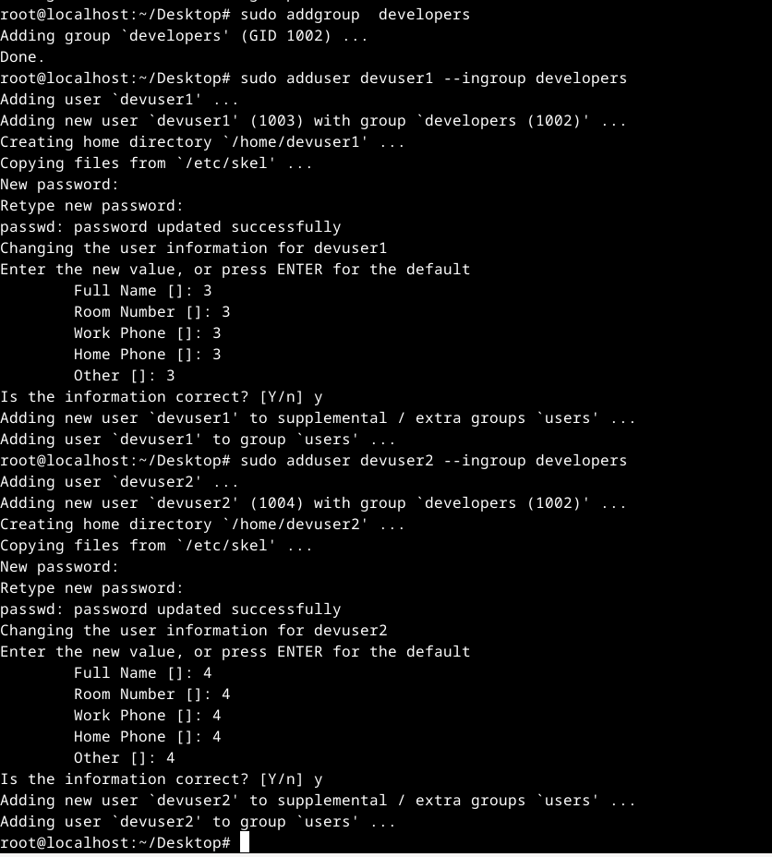

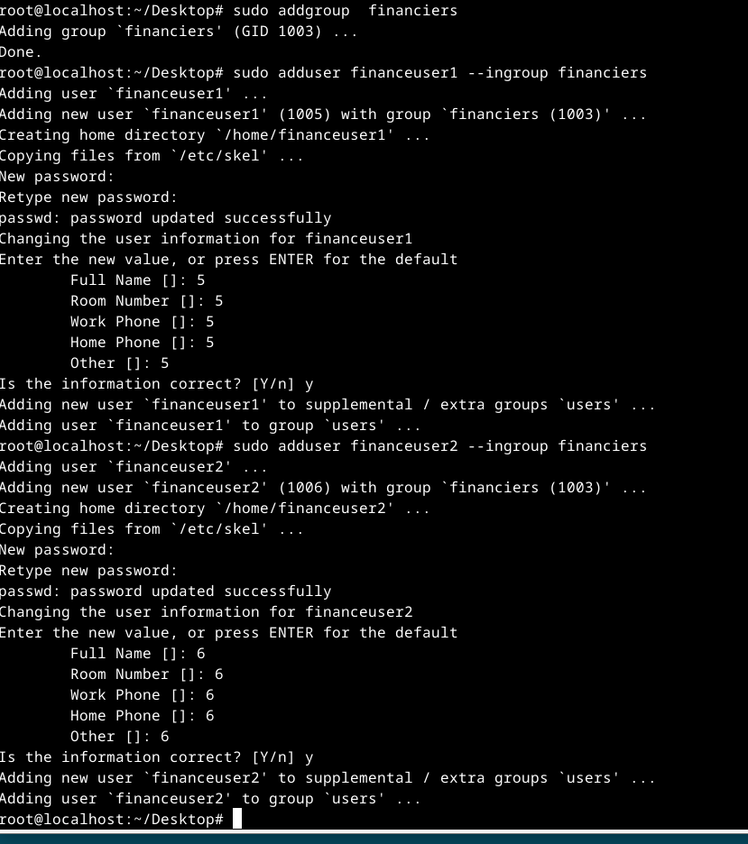

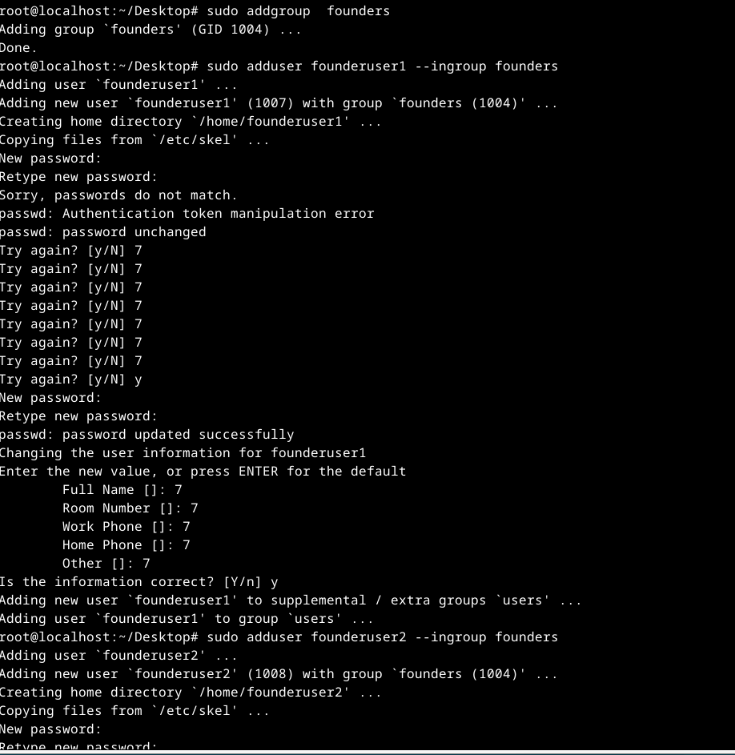

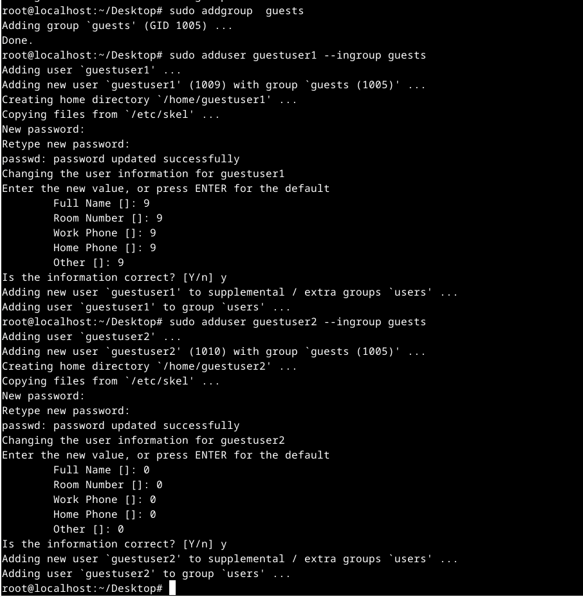

3. For each user, define its default command interpreter: робила Андрущик Поліна

- Technical support – bash;

- Developers – command interpreter 1 (task 1);

- Financiers – deny access to command interpreters;

- Founders – command interpreter 2 (task 1);

- Guests – deny access to command interpreters.  
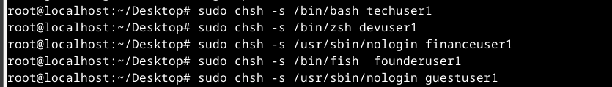  
  
4. Demonstrate examples of how each user group works in their command interpreter - for example, gathering information about the system, determining the basic configuration, system date, current directories, etc.  
